**Project Title:** Object Detection in X-ray Images

Group name: Oasis

Team member: Nattapat Juthaprachakul, Rui Wang, Siyu Wu, Yihan Lan

 Table of contents:

1. Motivation and Background
2. Problem Statements
3. Data Science Pipeline
4. Methodology
5. Evaluation
6. Data Product
7. Lessons Learnt
8. Summary

**1. Motivation and Background:** Who cares about this project? Any related work?

Everyday millions of people are travelling on public transport such as subways and civil airliners. Security inspection such as baggage screening has been playing a critical role in security risk and clearance process by helping protect public space from safety hazard such as terrorism. However, together with the growth of population in cities and more usage in public transportation, history has shown that people want security without having to undergo substantial inconvenience. Therefore, it is very important for us to design the system that can help speed up and increase the efficiency of the security inspection process. With the accelerating pace of development in Deep learning such as Convolutional Neural Networks, its application has shown the usefulness in many fields such as Machine Translation and Image Processing. For example, it can help fast, automatically and accurately discover and classify objects. In this project, we will explore several Deep learning-based Object Detection models to detect and classify prohibited objects in X-ray images and compare their performances on different metrics.

 As one of the fundamental computer vision problems, object detection is able to provide valuable information for semantic understanding of images and videos, and is related to many applications, including image classification, human behavior analysis, face recognition and autonomous driving. In our study, we concentrated on generic object detection, which aims at locating and classifying existing objects in any one image, and labeling them with rectangular bounding boxes to show the confidences of existence. Many previous researches have been conducted in this area, which could help us in this project. R. Girshick, J. Donahue, T. Darrell, and J. Malik[29] elaborated the r-cnn model; after several months, R. Girshick[30] improved the r-cnn model by reducing the training time and created the fast-rcnn model; and one year later, S. Ren, K. He, R. Girshick, and J. Sun[31] introduced the faster-rcnn model, which curtailed the training time dramatically. In 2017, K. He, G. Gkioxari, P. Doll ́ar, and R. B. Girshick[32] described a new architecture which is the mask r-cnn, which could locate exact pixels of each object instead of just bounding boxes. Different from these region proposal based methods, some previous researches also introduced another method which is known as the regression/classification based method. D. Erhan, C. Szegedy, A. Toshev, and D. Anguelov[33] introduced the MulitBox in 2014; J. Redmon, S. Divvala, R. Girshick, and A. Farhadi[34] invented the YOLO in 2016; after thatJ. Redmon and A. Farhadi[35] introduced a faster way called YOLO v2; in 2016, another research team including W. Liu, D. Anguelov, D. Erhan, C. Szegedy, S. Reed, C.-Y. Fu, and A. C. Berg[36] elaborated the ssd model, which, compared to the faster r-cnn,  could have a comparative accuracy performance with a lower input image resolution. All of these region proposal based frameworks and The regression/classification based frameworks lay the foundation for our project.

**Dataset:** SIXray dataset consists of X-ray images from Beijing subway <https://github.com/MeioJane/SIXray>

**Credit:** (@INPROCEEDINGS{Miao2019SIXray, author = {Miao, Caijing and Xie, Lingxi and Wan, Fang and Su, chi and Liu, Hongye and Jiao, jianbin and Ye, Qixiang }, title = {SIXray: A Large-scale Security Inspection X-ray Benchmark for Prohibited Item Discovery in Overlapping Images}, booktitle = {CVPR}, year = {2019} })

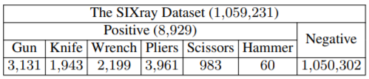

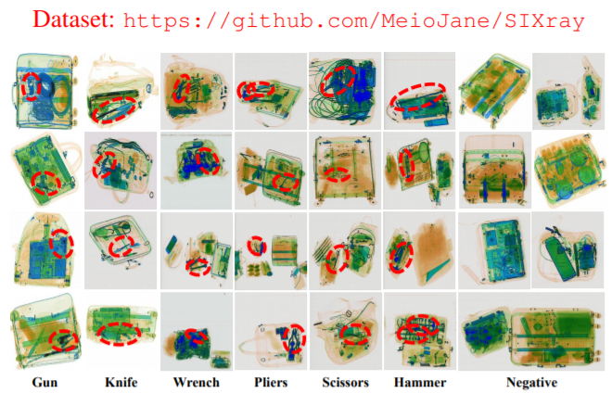

**2. Problem Statement:** What questions do you want to answer? Why are they challenging?

The goal of this project is to find the best algorithms that can detect prohibited objects in the X-ray images by selecting multiple algorithms, training multiple models, and reporting on comparative performance of each one. Performance of the model is described by mean average precision scores(Object Detection metrics), also including Accuracy and Recall scores. And the following section are the problems that we are trying to solve and why they are challenging.

**2.1  Algorithms(Object Detection vs Image Classification)**

In the image classification, CNNs are used as a feature extractor (extracting features directly using all pixels in the image). These features are later used as basic information for detecting and classifying prohibited items in our X-ray images. However, the method of extracting features using all pixels is too expensive and brings in a large amount of redundant information. In addition, a standard CNN followed by a fully connected layer has constant because the number of occurrences of the prohibited items need to be fixed. However, in our dataset, there could be many prohibited items with the same or different classes within one image, as well as several non-interest items. Another problem could be that the prohibited items might have different spatial locations within the image and different aspect ratios. Also, we need to select a large number of different regions and aspects of images, resulting in expensive computation cost and time.  Therefore, this dataset is well-suited for Object Detection algorithms instead. For Object Detection, the goal is not only to classify the prohibited objects but also to locate them by creating a bounding box around the object of interest.

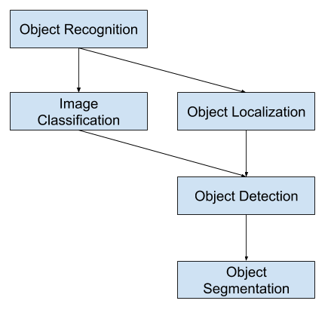

Credit: <https://machinelearningmastery.com/object-recognition-with-deep-learning/>

**2.2 Imbalanced Dataset**

The second problem is that our dataset is highly imbalanced. Our dataset has many more negative samples than positive samples. Negative samples mean that the image does not contain an object of our interest. On the other hand, the positive samples mean that the image contains objects of interest. In this case, the objects we try to detect are prohibited items in an X-ray image such as Knife, Gun, Wrench, Plier, and Scissors.

However, the benefit of using object detection models instead of classification models is that we are able to train enough positive samples without incorporating negative images into our training because negative samples exist implicitly in the images. All regions of the images that do not correspond to a bounding box are a negative sample. Therefore, we are able to save time and cost for training large dataset without much decrease in accuracy due to the imbalanced dataset.

**2.3 Challenging Images**

Lastly, our dataset is an X-ray image dataset that has problems with not only imbalanced dataset but also unclear images. By nature, security inspection often deals with baggage containing several items that are clustering, overlapping, and randomly stacking. The normal objects and prohibited items are mixing together in an arbitrary manner, leading to major detection problems like false inspection or ignorance by current technology like metal detectors or even human inspectors.

However, by carefully choosing proper Object Detection models, this challenging problem can be solved by the models that not only specify prohibited items correctly but also locate them precisely in the clustering images. In the next section, we will explain in the section about architecture behind each model our project has selected to use.

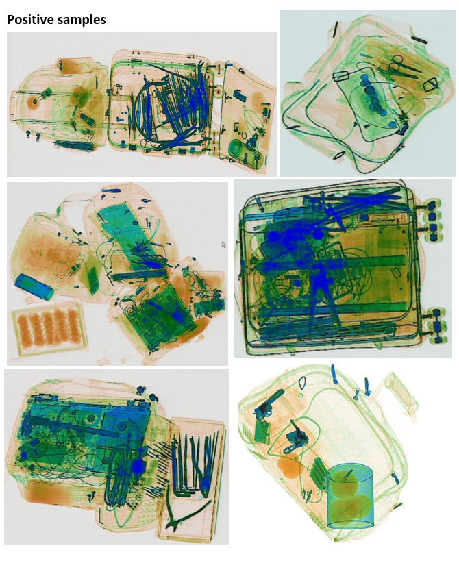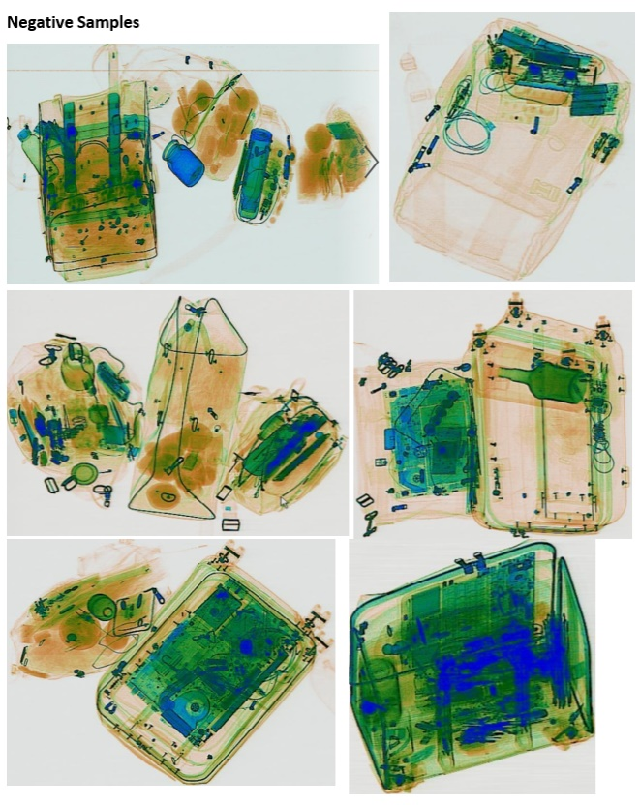

**3. Data Science Pipeline:** What's your data-science pipeline like? Describe each component in detail.

**3.1 Obtaining dataset**

SIXray dataset contains Positive samples(the images containing objects of interest namely prohibited items that we want to localize/classify) and Negative samples (the images containing non-prohibited items) which are later used for evaluating our models. In addition, the label files for whole images are in 3 separate folders. The location annotation files of objects of our interest are in .xml files.

**3.2 Pre-process images and label files to create training data**

We use a subset of Positive samples for Training and another subset of Positive samples combining with Negative samples for Testing/Evaluating. Due to limitations on computation cost and power, in this project we do not use the whole SIXray dataset. There are three main pre-processing steps for our dataset.

The first step is to get correct labels for each image we intend to use. Since we are using a subset of the main dataset, we need to get new labels for each image from our dataset. Later, these labels are used for Testing/Evaluating of models.  
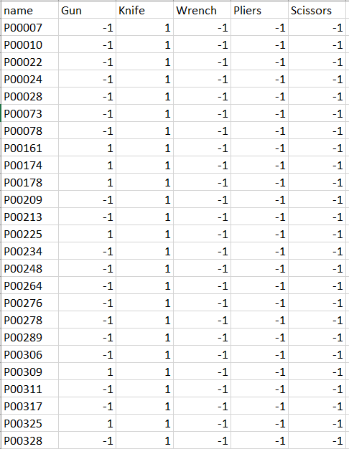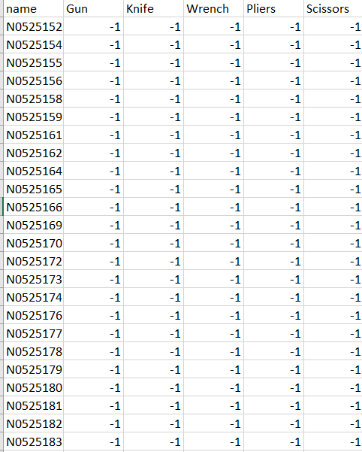

The second step is to create readable data files by combining real images with metadata of those images such classes and location of the objects in the images.

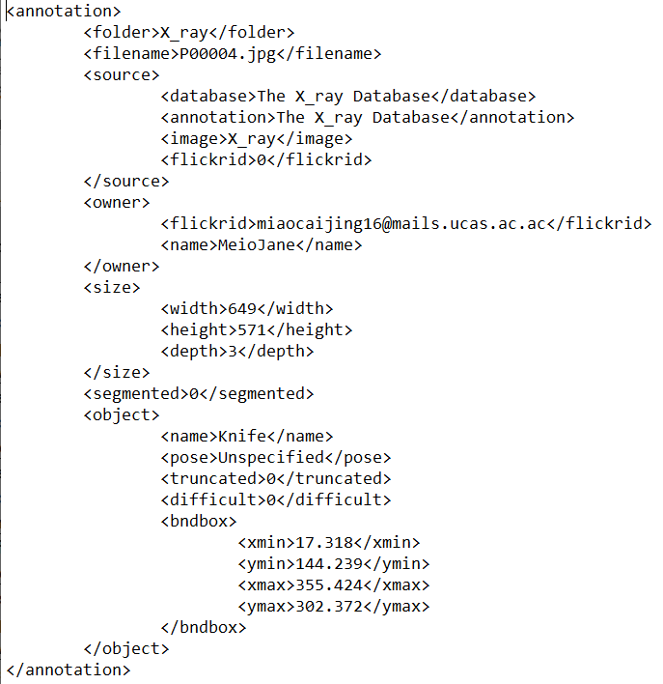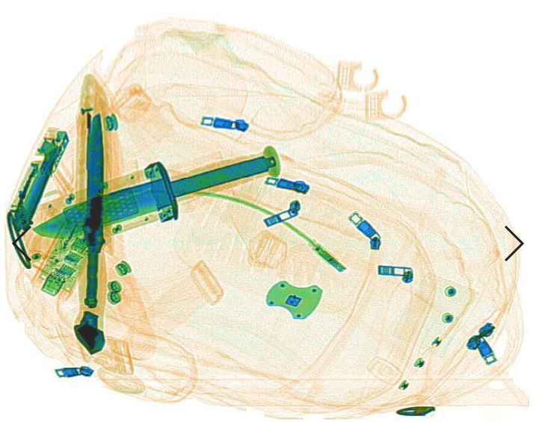

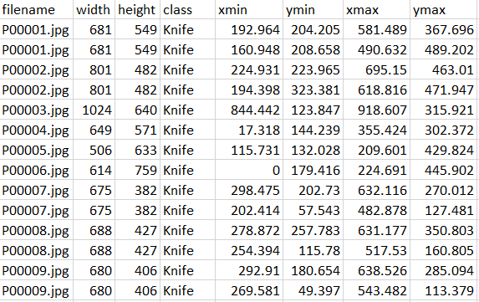

The last step is to turn images and annotation files of Positive samples into Tensorflow Record for training in our Object Detection models.

**3.3 Creating Training pipeline and training models**

Our training is done by Tensorflow Object Detection API where we can download and install from the link below together with Config files and Pre-trained Models from a Tensorflow model zoo. Also, we have tried the Classification model but it does not work well. Therefore, we changed to the Object Detection model instead.

Tensorflow Object Detection API: <https://github.com/tensorflow/models/tree/master/research/object_detection>

Tensorflow Object Detection Model Zoo:

<https://github.com/tensorflow/models/blob/master/research/object_detection/g3doc/detection_model_zoo.md>

Tensorflow Object Detection config for each model:

<https://github.com/tensorflow/models/tree/master/research/object_detection/samples/configs>

The training is done on Google Cloud Platform with Deep Learning VM. We trained eight different Object Detection models.



The total number of images for training is 7,200 Positive samples. In this project, we did not incorporate Negative samples to our training set as the Detection Models use the parts of the image that do not belong to the annotated objects as negative samples. In addition, the training process is monitored by the Tensorboard where we can set up and see our training progress online such as numbers of steps finishing, training loss, validation loss, and etc.

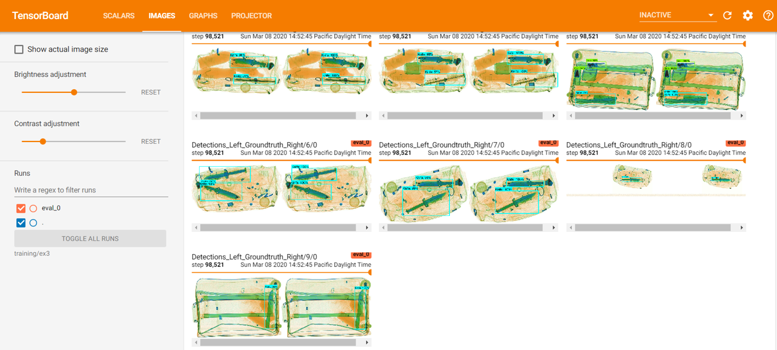

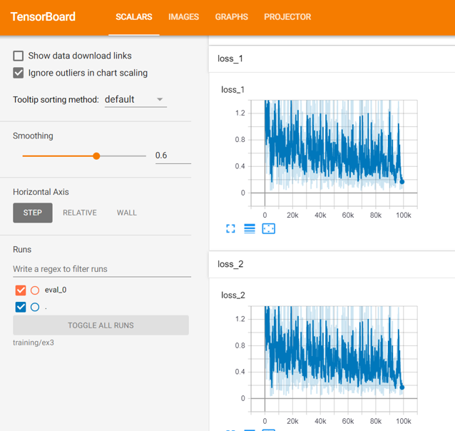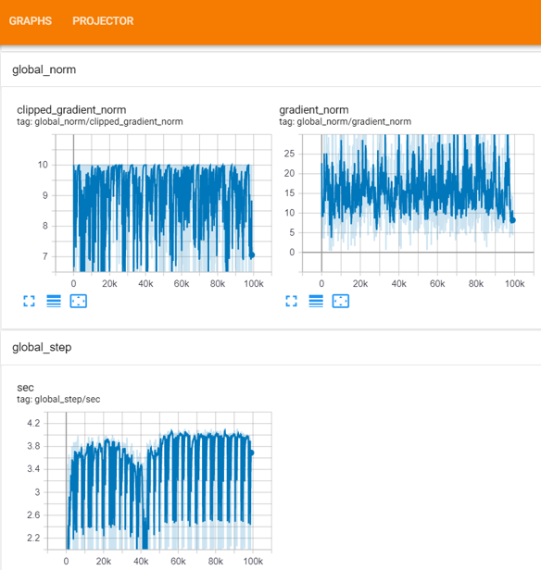

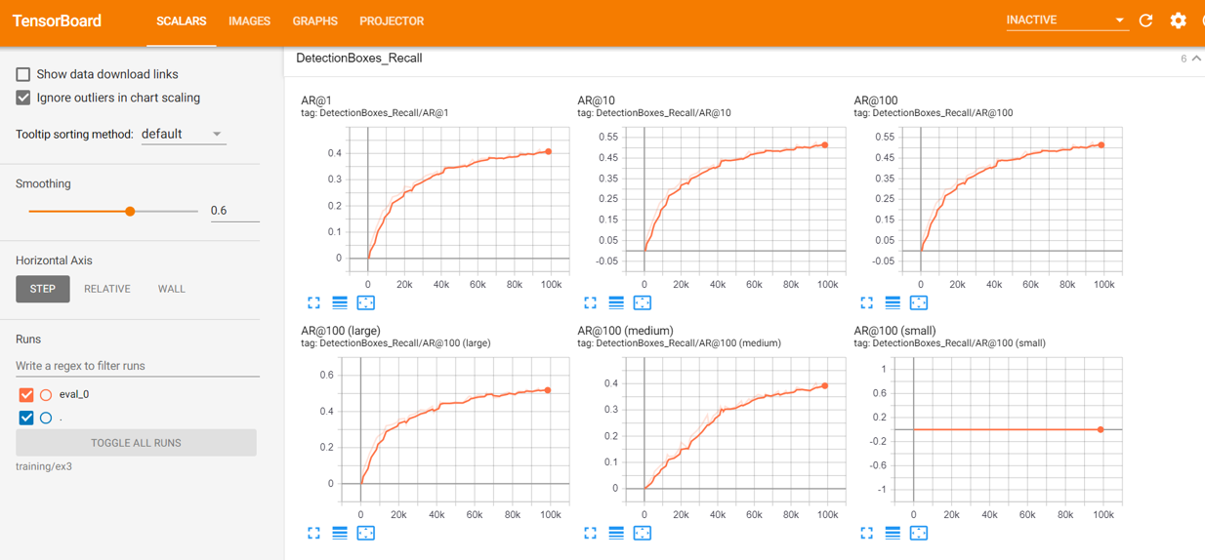

**3.4 Evaluating each model with different ratios of negative-positive image sets**

We create an Inference graph from our trained model and use it to evaluate with another subset of Positive samples and a whole set of Negative samples. The performance is measured by precision-recall score and mean Average Precision scores (mAP).

Three ratios of dataset for model evaluation:

1. 1,800 Positive Samples + 50,000 Negative Samples
2. 1,800 Positive Samples + 100,000 Negative Samples
3. 1,800 Positive Samples + 150,000 Negative Samples

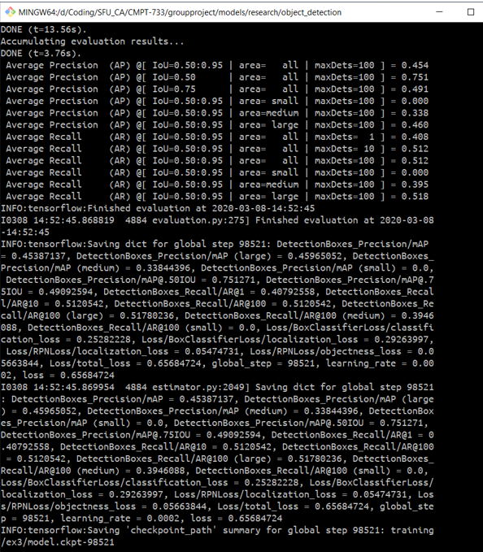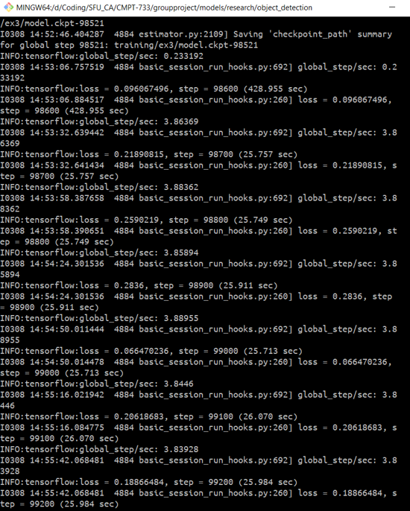

**4. Methodology:** What tools or analysis methods did you use? Why did you choose them? How did you apply them to tackling each problem?

For Image Classification, by taking an image input and predicting the object in that image, a model classifies what is contained in an image while Image Localization specifies the location of objects in an image. However, the localization alone will not help us predict the class of the object in the image. On the other hand, Object Detection specifies the location of the object in the image and predicts the class of that object. Therefore, in this project, this makes the Object Detection model well-suited for our X-ray dataset.

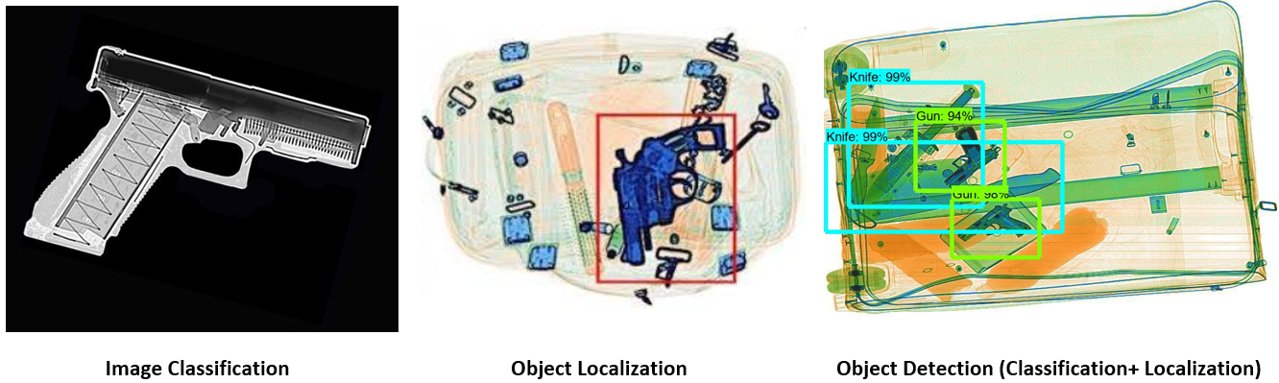

In our project we are using up to eight Object Detection models with different structures as described by the following sections.

1. SSD_mobilenet_v1
2. SSD_mobilenet_v1_fpn
3. SSD_inception_v2
4. SSD_resnet50
5. RFCN_resnet101
6. Faster_RCNN_resnet50
7. Faster_RCNN_resnet101
8. Faster_RCNN_inception_v2

**4.1 Object Detection Architectures**

* **SSD (Single Shot MultiBox Detector)** [**https://arxiv.org/abs/1512.02325**](https://arxiv.org/abs/1512.02325)

SSD is an approach for detecting objects in images using a single deep neural network, which discretizes the output space of bounding boxes into a set of default boxes over different aspect ratios and scales per feature map location. At prediction time, the network generates scores for the presence of each object class in each default bounding box and produces adjustments to the box to better match the object shape.

SSD is simple relative to methods that require object region proposals because it completely encapsulates all computation in a single network(VGG16 network as a feature extractor which is equivalent to the CNN in Faster R-CNN). It makes SSD easy to train, fast to detect, and straightforward to be integrated into systems that require a detection component. Because of Pyramidal Feature Hierarchy structure, it has a fast detection speed but has low performance in detecting small objects as it misses the opportunity to reuse the higher resolution maps of the feature hierarchy. (SSD only uses upper layers for detection as shown in the following picture)

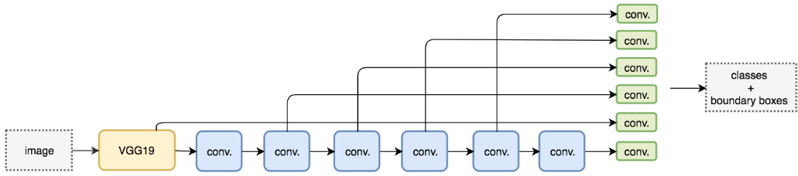

Credit:<https://medium.com/@jonathan_hui/what-do-we-learn-from-single-shot-object-detectors-ssd-yolo-fpn-focal-loss-3888677c5f4d>

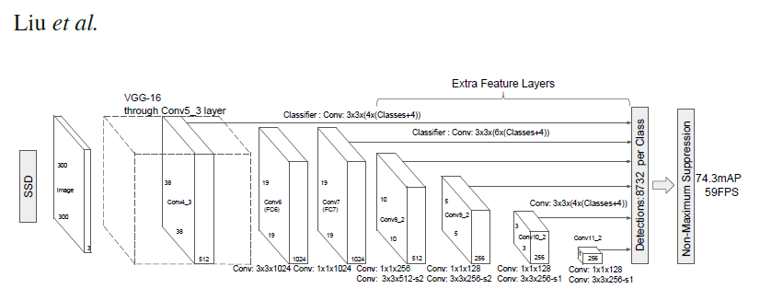

* **Feature Pyramid Network (FPN)** [**https://arxiv.org/abs/1612.03144**](https://arxiv.org/abs/1612.03144)

FPN consists of two main pathways: bottom-up pathway, a low-resolution and semantically strong feature, with top-up pathway, high-resolution with semantically weak features. Also, the network adds lateral connections to help connect between reconstructed layers and corresponding feature maps to help the detector to predict the location betters. This overall feature pyramid has rich semantics at all levels and is built quickly from a single input image scale, thereby without sacrificing representational power, speed, or memory.

          In summary, FPN is a feature extractor developed for building high-level semantic feature maps at all scales(pyramid concept). FPN shows improvement as a multi-scale feature extractor with better quality information over other normal feature extractor in object detection models like Faster RCNN models.

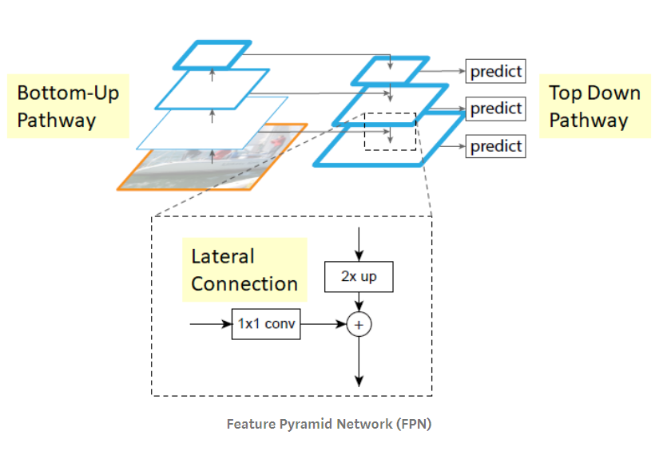

Credit:<https://medium.com/@jonathan_hui/understanding-feature-pyramid-networks-for-object-detection-fpn-45b227b9106c>

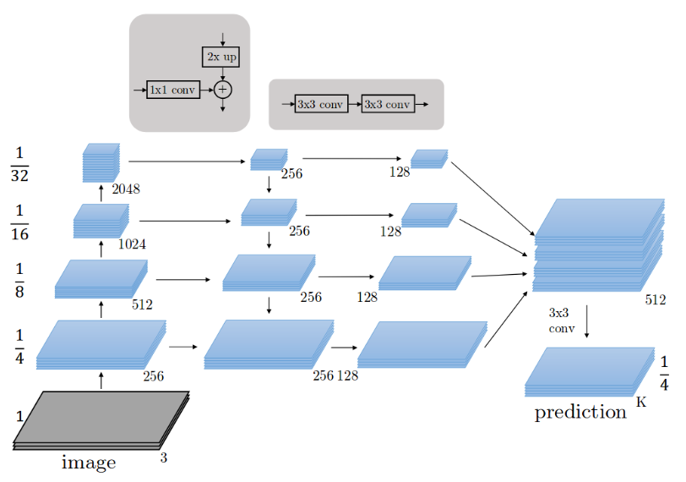

Credit:<http://presentations.cocodataset.org/COCO17-Stuff-FAIR.pdf>

* **Faster R-CNN (Region-based Convolutional Network)** [**https://arxiv.org/abs/1506.01497**](https://arxiv.org/abs/1506.01497)

In naive approach for object detection algorithms, we can apply CNN models on one single image in order to detect an object of our interest by applying different sliding windows for different regions several times. This approach is very computationally expensive and time consuming. Therefore, there is an attempt to reduce the number of sliding windows.

By introducing R-CNN, Ross Girshick proposed a selective search method to extract 2000 regions from an image and these regions are called ‘region proposals’.   Selective search uses local cues like texture, intensity, and color to generate all the possible locations of the object.  The CNN acts as a feature extractor for each candidate region. Lastly, a linear SVM classifier is used to classify the presence of the object within that candidate region proposal. However, R-CNN is still computationally expensive to train since there are 2,000 region proposals per image.

The same author introduces the upgraded model called Fast R-CNN that has a very similar approach such as selective search to the old model with some new technique, resulting in less computation. Instead of selecting 2,000 fixed region proposals, a set of region proposals are extracted by two main operations. The first operation is a feature extraction operation by CNN models and output is called a convolutional feature map. The second operation is to use a region of interest pooling layer (RoI) to identify the region proposals from the output of the first operation.

As a selective search approach is very time consuming,a new model is proposed called Faster R-CNN by different authors. Instead of using selective search algorithms, the separate new network is introduced to select region proposals. This makes Faster R-CNN faster than both R-CNN and Fast R-CNN.

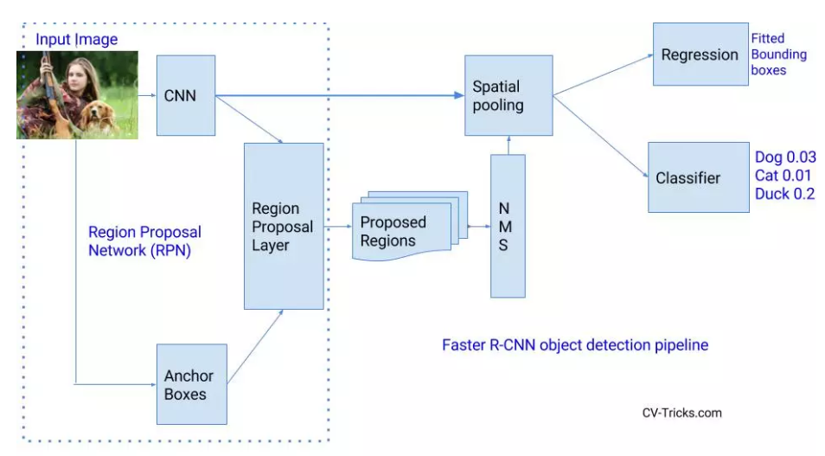

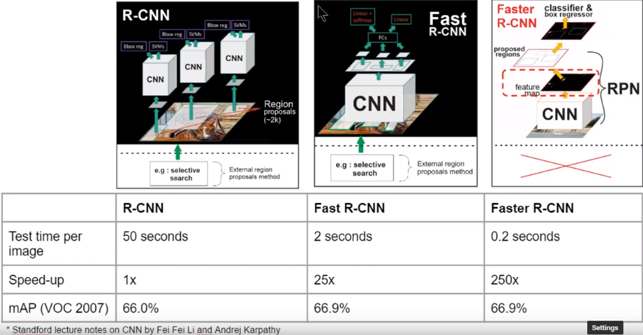

* **R-FCN (Region-based Fully Convolutional Networks)** [**https://arxiv.org/abs/1605.06409**](https://arxiv.org/abs/1605.06409)

According to authors of the paper, in contrast to previous region-based detectors such as R-CNN, Fast R-CNN, and Faster R-CNN that apply a costly per-region subnetwork hundreds of times, a new region-based detector called R-FCN is fully convolutional with almost all computation shared on the entire image. The authors propose position-sensitive score maps to address a dilemma between translation-invariance in image classification and translation-variance in object detection. Therefore, this method can thus naturally adopt fully convolutional image classifier backbones such as the latest Residual Networks(Resnet) for object detection.

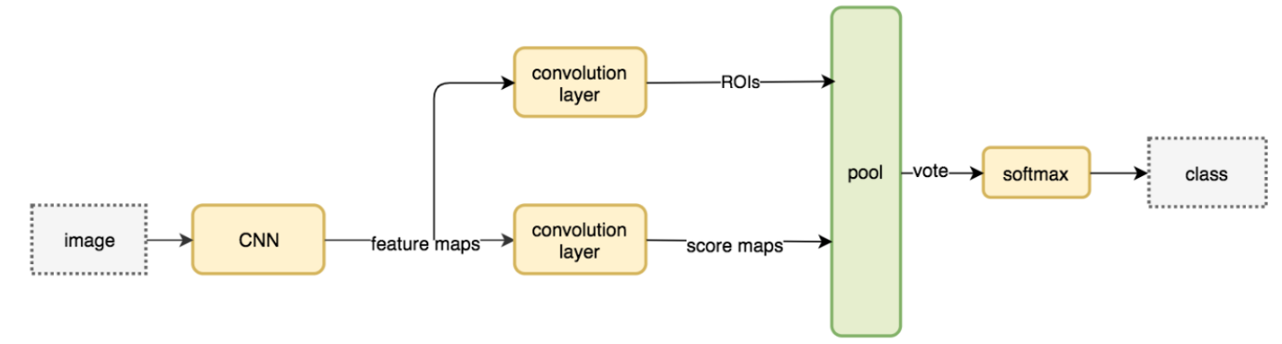

Credit: <https://medium.com/@jonathan_hui/understanding-region-based-fully-convolutional-networks-r-fcn-for-object-detection-828316f07c99>

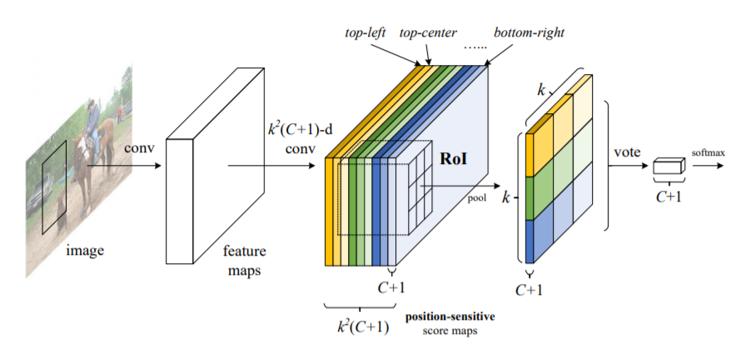

Credit: [**https://arxiv.org/abs/1605.06409**](https://arxiv.org/abs/1605.06409)

* **Model Comparisons between Accuracy and Speed**

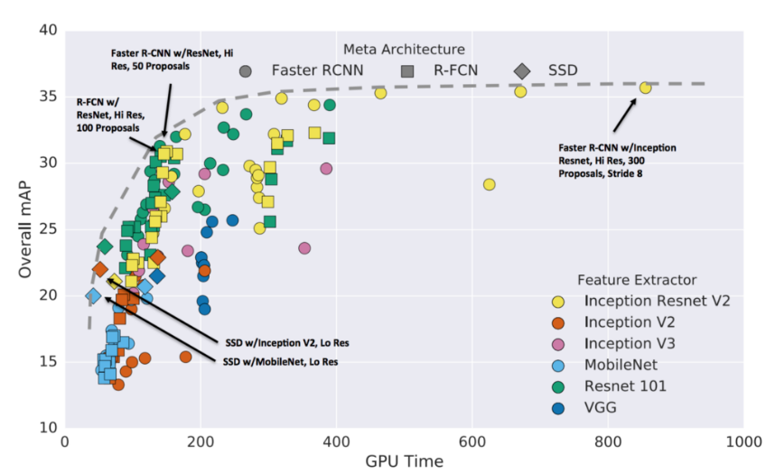

Credit: <https://mc.ai/object-detection-speed-and-accuracy-comparison-faster-r-cnn-r-fcn-ssd-and-yolo/>

**4.2 Key features of the underlying CNN models used as backbone for Object Detection models:**

* **Resnet50 and Resnet101** <https://arxiv.org/abs/1512.03385>

Resnet is a very deep network with many layers(Resnet101 has a deeper network than Resnet50). It is the very first network to use skip connection in order to solve the problem of decreasing accuracy(vanishing gradient) as the network gets deeper and apply the batch normalization technique.

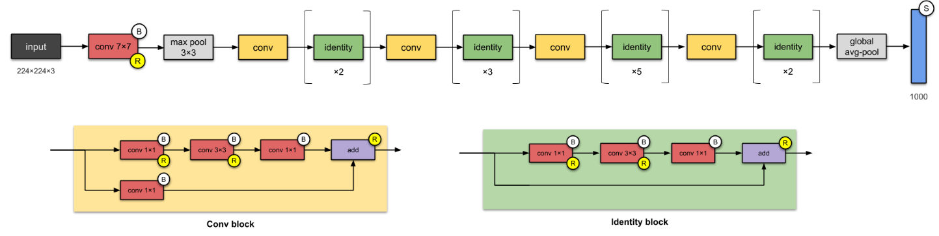

* **Inception v2** <https://arxiv.org/pdf/1512.00567v3.pdf>

There are three main notable components of Inception_v2 architecture. Firstly, it introduces two additional auxiliary classifiers in the middle of the network in order to solve the vanishing gradient problem. Secondly, because of different sizes of filters in the same layer, it has deeper and wider networks compared to Resnet. Lastly, due to the problem of reducing the size of inputs drastically leading to information loss, the network has been upgraded from Inception_v1 by implementing two 3x3 convolution operations instead one 5x5 as to solve the problem of representational bottleneck.

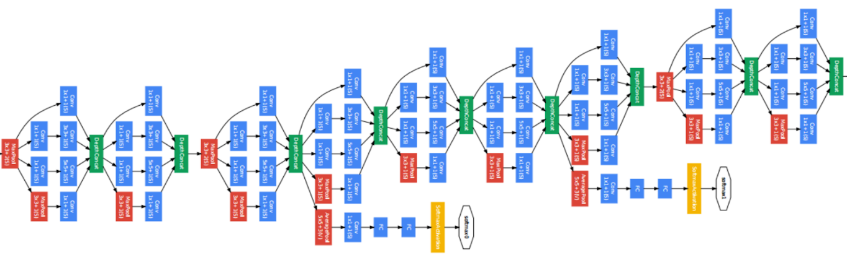

* **Mobilenet v1**  <https://arxiv.org/abs/1704.04861>

The notable key feature of Mobilenet is that it uses depth-wise separable convolutions to build light-weight deep networks. This means that the network applies depthwise convolution before applying a normal pointwise convolution.  A regular convolution does both filtering and combining in a single operation. However, with a depth-wise separable convolution, these two operations are done as separate steps, resulting in faster computation.

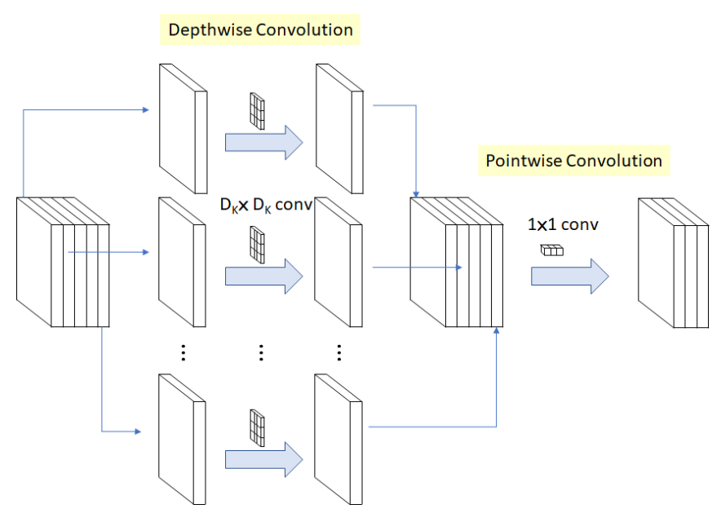

Credit: <https://towardsdatascience.com/review-mobilenetv1-depthwise-separable-convolution-light-weight-model-a382df364b69>

* **Model Comparisons between Accuracy and Speed**

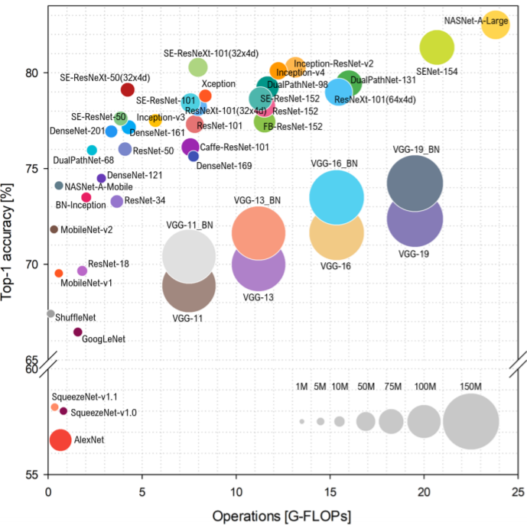

Credit: <https://arxiv.org/pdf/1810.00736.pdf>

Note:

 1. Complexity can be expressed in terms of floating point operations or flops required to find the solution, meaning that a Flop serves as a basic unit of computation and the number of flops indicates the cost of performing a sequence of operations.

2. Inception v3 has the same architecture as Inception v2 with minor changes.

From the graph above, in terms of computation time, we can arrange from fastest to slowest computation for each model backend we use as the following: Resnet101, Inception_v3, Resnet50, and Mobilenet_v1. On the other hand,  in terms of accuracy, we get Inception_v3, Resnet101, Resnet50, and Mobilenet_v1.

**5. Evaluation:** Why is your solution good? Why does your result make sense?

Evaluating Object Detection models consists of two main distinct tasks that require us to measure. The first is a Classification task which is to determine whether there is an object of our interest in the image. The second task is a Localization task which is to determine the location of the object of our interest in the image. In addition, our dataset is both highly imbalanced between positive and negative samples and non-uniformly distributed among different classes of prohibited objects. Therefore, using accuracy metrics alone would not be enough as we also need to assess how likely our models misclassify objects and non-objects of our interest. Hence, a model score or confidence score is evaluated based on each bounding around the objects of our interests in the images in order to assess both object locations and classes of our models at a variety of thresholds. The Average Precision(AP) is the main measurement used in Object Detection. We need to understand some important underlying concepts behind it such as Precision-Recall curve, Average Precision and Intersection over Union threshold(IoU).

**5.1 Intersection over Union threshold(IoU)**

The most important threshold in selecting whether our models can classify the classes of prohibited objects and predict the location of those objects in the images or not is Intersection over Union threshold(IoU). IoU is defined as an overlapping area of the intersection divided by the area of the union of a ground-truth bounding box  from test images and a predicted bounding box from our models.

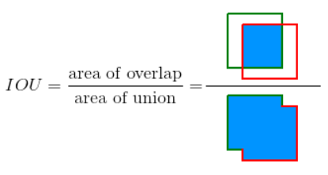

Credit: <https://github.com/rafaelpadilla/Object-Detection-Metrics>

**5.2 Precision-Recall curve**

Precision-Recall metric as our useful measure of success of prediction when the classes are highly imbalanced.

**Precision(P)** is defined as the number of true positives(Tp) over the number of true positives plus the number of false positives (Fp). [P = Tp /(Tp+Fp)]

**Recall(R)** is defined as the number of true positives(Tp) over the number of true positives plus the number of false negatives (Fn). [R = Tp/(Tp+Fn)]

In order to assess those metrics, we need to manually pick some thresholds to consider the direction of our prediction and then we can average them later for every threshold picked.

**True Positive(Tp)** is a correct detection where IoU ≥ threshold.

**False Positive(Fp)** is an incorrect detection where IoU < threshold.

**False Negative(Fn)** is a missing detection on objects of our interests.

**True Negative(Tn)** is an implicit measurement for the Object Detection model as bounding boxes for True Negative are bounding boxes for non-objects of our interests. Therefore, there are many possible bounding boxes for non-objects of our interests within each image. This is why we do not need to explicitly measure True Negative since other measures mentioned above can perform very similar tasks in an opposite direction.

Therefore, Precision is the ability of our models to detect ONLY the relevant OBJECTS of our interests while Recall is the ability of ours to find ALL the relevant BOUNDING BOXES of objects of our interests.

The important observation from Recall and Precision formula is that the Precision may not decrease with Recall. The definition of precision Tp/(Tp+Fp) shows that lowering the threshold of our models may increase the denominator by increasing the number of all relevant results returned. If the threshold was previously set too high, the new results may all be True Positives which in turn will increase Precision. However, if the previous threshold was about right or too low, further lowering the threshold will introduce False Positives which in turn decrease Precision. On the other hand, Recall is defined as Tp/(Tp+Fn) where Fn does not depend on the selected threshold. This means that lowering the threshold may increase Recall by increasing the number of True Positive results. Consequently, it is possible that lowering the threshold may possibly cause Precision to fluctuate while Recall is unchanged. However, selecting the right thresholds is hard; therefore, we would rather find the possible thresholds and average them. This is why Average Precision is important.

The Precision-Recall curve shows the tradeoff between Precision and Recall for different thresholds. A high area under the curve represents both high Recall and high Precision where high Precision relates to a low False Positive rate and high Recall relates to a low false Negative rate. High scores for both show that our models are returning accurate results (high Precision), as well as returning a majority of all positive results (high Recall).

Models with high Recall but low Precision locate bounding boxes around the objects of our interests; however, most of their predicted classes of those objects are incorrect when compared to the true labels. Models with high Precision but low Recall are just the opposite. By locating few relevant bounding boxes, but most of their predicted classes are correct when compared to the true labels. In summary, we want models with both high Precision and high Recall since they will return many relevant bounding boxes with all results labeled correctly.

**5.3 Average Precision(AP) and Mean Average precision(mAP)**

Average precision(AP) summarizes the Precision-Recall curve as the weighted mean of Precisions achieved with the increase in Recall from the previous threshold used as the weight at every threshold level. [AP=∑n(Rn−Rn−1)Pn ] where Pn and Rn are the precision and recall at the nth threshold. From the above formula, AP is the Precision averaged across all Recall for every threshold. On the other hand, Mean Average Precision(mAP) is defined as the mean of Average Precision across all different classes. However, there are two different types of mAP: Micro mAP and Macro mAP. A Macro mAP computes an AP metric independently for each class of objects of our interests and then computes the average. This means that Macro mAP treats all classes equally. In contrast, a Micro mAP will aggregate the contributions of all classes to compute the AP metric. As our dataset is highly imbalanced, Micro mAP is more suitable for evaluating our models..

* **Result**

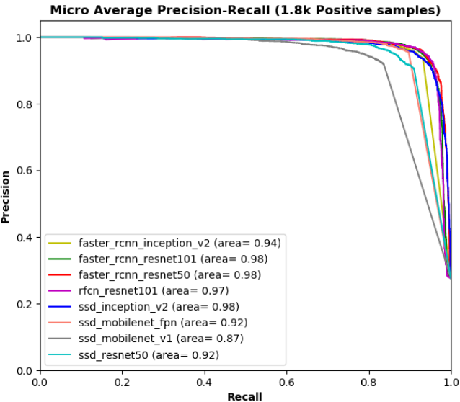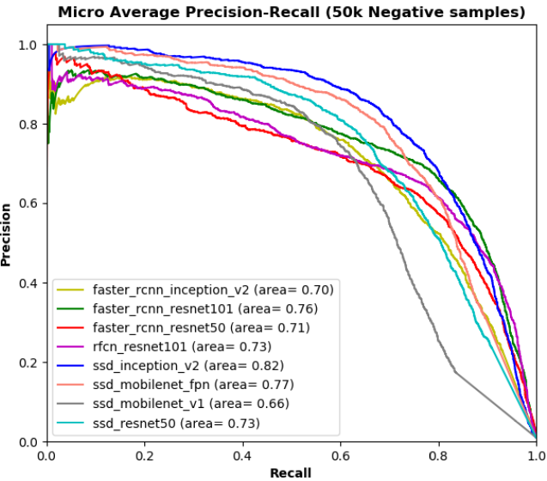

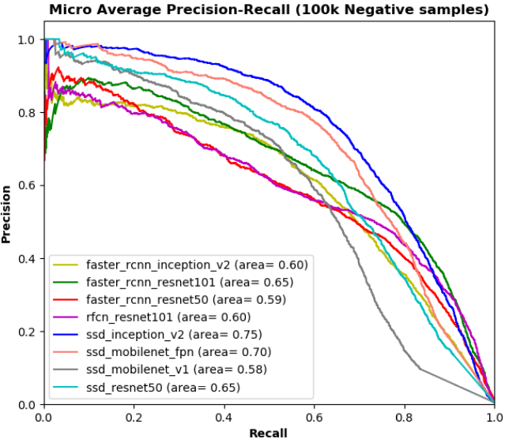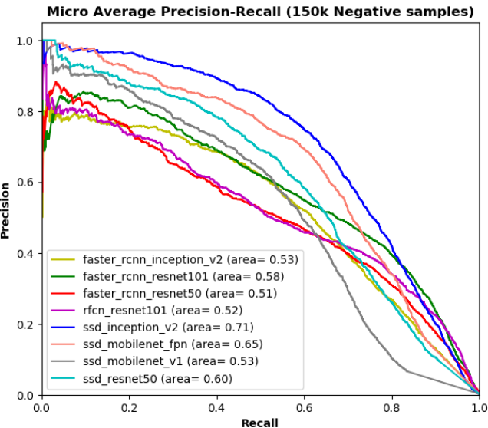

We train all of our models with 7,200 Positive samples while evaluating with another 1,800 Positive samples together with different numbers of Negative samples namely: 50,000, 100,000, and 150,000 respectively.  All of the above graphs are Micro Average Precision-Recall curves of different models with the dataset with different ratios of Positive and Negative samples. The higher the areas under curves, the higher both the Precision and Recall at every threshold.

  In the top-left image, we test our models with only 1,800 Positive samples without any Negative samples. The areas under curves for each model are very high though SSD_Mobilenet_v1 might have a lower area under curve compared to others. The rest three images show the performance of each model when testing them with different subsets of the dataset namely 50,000, 100,000, and 150,000 Negative samples. The SSD_Inception_v2 model has the highest area under curve compared to others in every test dataset. Additionally, in every ratio between Positive and Negative samples of our test datasets, SSD-based models such as SSD_Mobilenet_v1_fpn and SSD_Resnet50 also have higher areas under curves than other model architectures like R-FCN and Faster R-CNN as well with an exception of SSD_Mobilenet_v1. The SSD_Mobilenet_v1 has the lowest area under curve in every test dataset. This implies that the performances of our models not only depend on Detection networks alone but also rely on network backends like CNN networks that are used for feature extraction as well. We can observe that SSD-based Detection models with Inception_v2, Mobilenet_v1_fpn, and Resnet50 outperform R-FCN and Faster R-CNN-based models with similar network backends. In comparison, the SSD-based model with a simple extraction network like Mobilenet_v1 performs the worst out of every model.

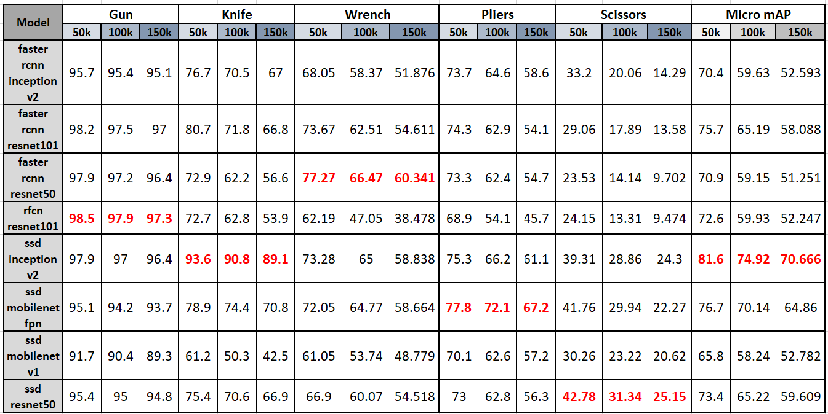

The above table shows the average precision of each model by different categories of dangerous items in different ratios of Positive-Negative samples in test datasets while the last three columns show Micro mean Average Precision summary for every class of prohibited objects of every model in different ratios of test datasets. The clear observation of this table is that as we include more Negative samples into test datasets, both average accuracy and micro Average Accuracy(mAP) are decreasing from 50k to 150k Negative samples correspondingly. For the Gun class, RFCN_Resnet101 has the best performance while the other models like Faster_RCNN_Resnet50/101 and SSD_Inception_v2 come very close. However, for the Knife class, SSD_Inception_v2 has the highest average accuracy and outperforms other models by a very large margin compared to other models. Both Gun and Knife class, our best models have average accuracy up to 90%. On the other hand, for both Wrench and Pliers class, Faster_RCNN_Resnet50 and SSD_Mobilenet_v1_fpn have the highest average accuracy respectively with a 60-80% range. However, for the Scissors class, SSD_Resnet50 is the best model with the highest average accuracy of just 20-40% range. This implies that the Scissors class might be the most difficult prohibited item to be detected; therefore, it would rather for a Machine Learning engineer to modify models or add more data with more Scissors class.

Overall, our projects implement micro mAP to assess the general performance of each model. The SSD_Inception_v2 has the highest mean Average Precision score(mAP) which follows our previous analysis on Average-Recall curves.

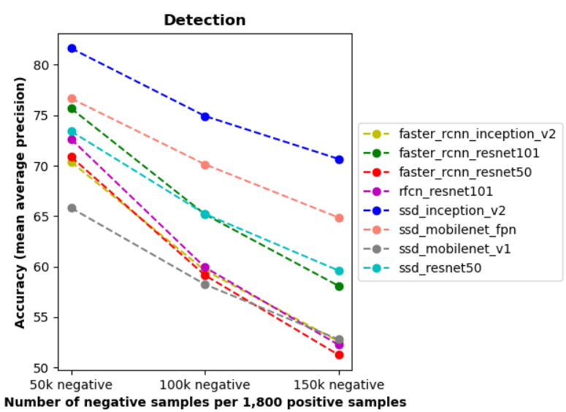

The lines chart above also summarized the last three columns of the previous table by using mean Average Precision scores of each model. SSD_Inception_v2 is the best model in our case which is followed by SSD_Mobilenet_v1_fpn; while the performance of SSD_Mobilenet_v1 is relatively disappointing among all of our models.

**6. Data Product:**

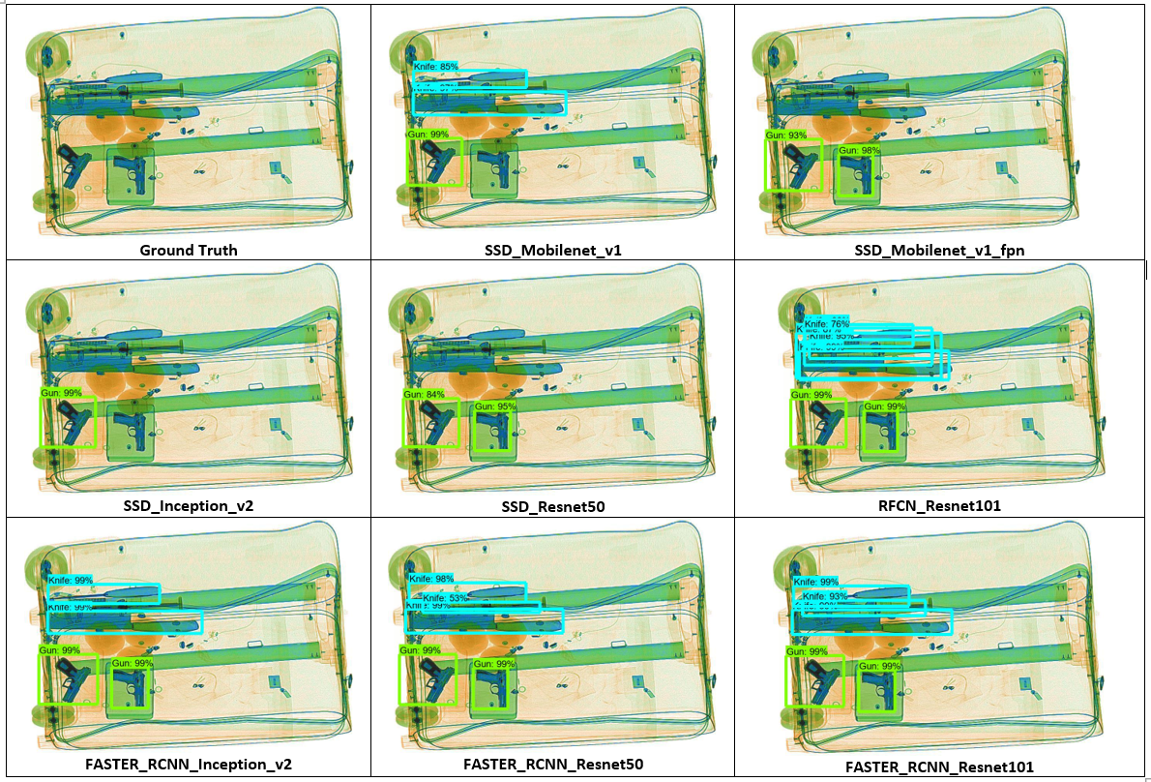

This test image showed the performances of our different trained Object Detection models together with a ground truth image. From the ground truth image, we can observe that there are four dangerous items in this baggage including two guns and three overlapped knives. Among all these models, SSD_Mobilenet_v1_fpn, SSD_Inception_v2 and SSD_Resnet50 are able to detect only guns while ignoring all the knives while the rest of our models could detect both guns and knives.  Both RFCN_Resnet101 and Faster_RCNN_Resnet101 have the best performance among other models because they can detect all four dangerous objects with very high accuracy though RFCN_Resnet101 puts more bounding boxes on the prohibited objects.

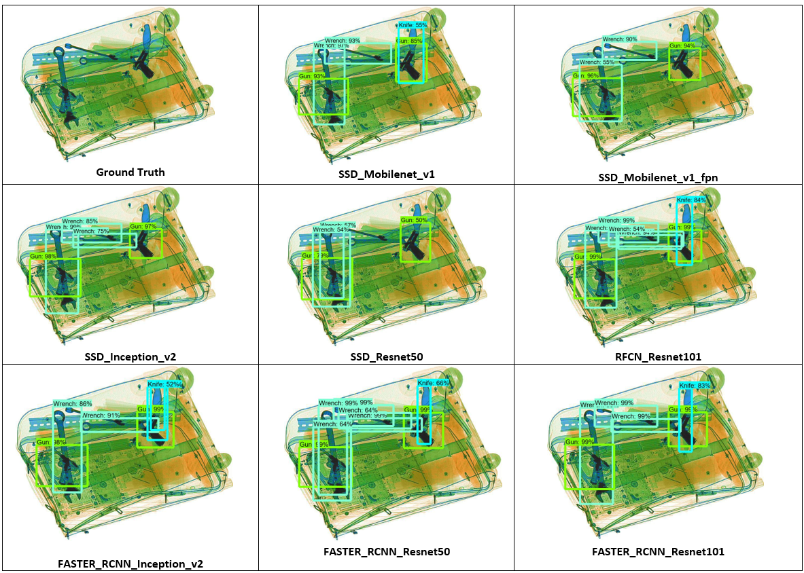

The second test image is more challenging than the previous one. There were three different types of dangerous items: wrench, gun, and knife with several numbers of them in one image. From the ground truth image, we could observe that there are three wrenches, two guns and one knife which randomly scatter and overlap on each other. SSD_Mobilenet_v1_fpn and SSD_Inception_v2 can detect wrenches and guns while missing the knife; whereas, other models except SSD_Resnet50 can detect all of these three kinds of prohibited objects. On the other hand, SSD_Resnet50 can detect both guns and wrenches with very low scores while missing a knife and one wrench entirely. RFCN_Resnet101, Faster_RCNN_Resnet101, and Faster_RCNN_Resnet50 performed the best in this case since they are able to identify all dangerous items and locate them with the highest accuracy scores.

**7. Lessons Learnt:**

Three important things we have learnt from this project are as follows: how the Object Detection model works, why we need Object Detection models, and how to assess the performance of Object Detection models.

Usually, we choose CNN models to solve the image classification problem; whereas, in this project CNNs failed to both identify and locate dangerous items in our X-ray dataset. For example, we have tried both VGG16 and Resnet50 models but the result was disappointing. To explain this phenomenon, we searched a lot and concluded some reasons including the expensive feature extraction problem, and different object location problem, which have been mentioned above. We also found a better alternative which is the Object Detection model. We learned many Object Detection structures, such as Faster R-CNN, SSD, R-FCN and FPN. We have explained its structure, features and advantages in detail in the previous sections for each of them. To implement Object Detection models, we use Tensorflow Object Detection API and set up the training pipeline on Google Cloud Platform. We have trained several models and evaluated their performances. In the evaluation part, we learned three new concepts including Precision-Recall curve, Average Precision and Intersection over Union threshold(IoU). We used Micro mAP as our main metrics to evaluate all trained Object Detection models and selected the model with the best performance.

**Future works:**

To improve the precision of our Object Detection models, we need to add more positive images, especially images with Scissors class. Our current dataset is both unbalanced in Positive and Negative samples (with 8,929 Positive and 1,050,302 Negative images) and unbalanced in numbers of images containing prohibited objects in each class. In addition, for our project, we only use Positive images to train our models though positive images only make up less than 1% and we still need some of them for the test dataset. In the future, we could integrate some Negative samples into our training dataset.

 Furthermore, among five types of dangerous items, identifying scissors seems to be very difficult for all of our models as the model with the best performance in detecting scissors can obtain only 42% accuracy in the smallest subset of our dataset. One possible reason behind this is the lack of scissors images in our training dataset since we only have 983 images with scissors in the training dataset which are far lower than other classes.

In addition, we could evaluate time and accuracy tradeoff among all of our models. As some applications require real-time Object Detection, the models with highest accuracy but slowest to train and evaluate might not be appropriate in this situation.

**8. Summary:** A high-level summary of your project. It should be self-contained and cover all the important aspects of your project.

In this project, we want to classify the image with certain items and locate all certain items. Due to the disappointing performance of CNN models, we choose to implement object detection models to achieve our goal. Plenty of object detection architectures, such as ssd, faster-rcnn, fpn and r-fcn, and many of CNN models including resnet, inception and mobilenet have been trained for classification and localization of certain items. To find out the most accurate model in this case, we assessed the performance of each model and used micro mean average precision to measure the general performance of each model in predicting different types of dangerous items. Ssd_inception_v2 was proved to be the most suitable model with the highest mean average precision score in this case. Some future work still needs to be conducted to optimize the performance of predicting scissors, and one possible solution is increasing the amount of training dataset.

**Additional Figures:**

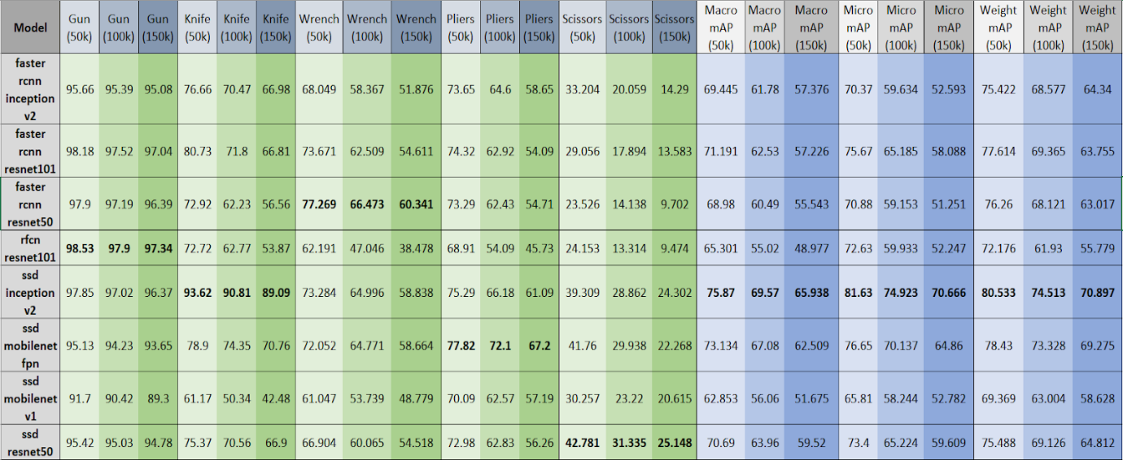

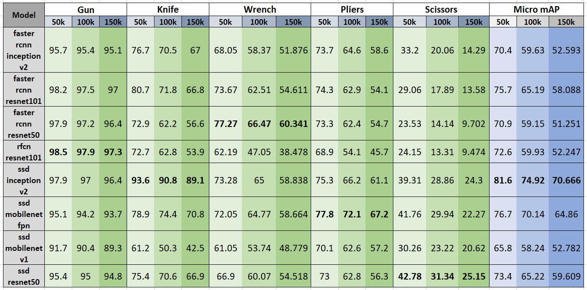

**References:**

1. <https://github.com/MeioJane/SIXray>
2. <https://arxiv.org/pdf/1901.00303.pdf>
3. <https://github.com/tensorflow/models/tree/master/research/object_detection>
4. <https://github.com/tensorflow/models/blob/master/research/object_detection/g3doc/detection_model_zoo.md>
5. <https://github.com/tensorflow/models/tree/master/research/object_detection/samples/configs>
6. <https://medium.com/@jonathan_hui/understanding-feature-pyramid-networks-for-object-detection-fpn-45b227b9106c>
7. <http://presentations.cocodataset.org/COCO17-Stuff-FAIR.pdf>
8. <https://arxiv.org/abs/1605.06409>
9. <https://medium.com/@jonathan_hui/understanding-region-based-fully-convolutional-networks-r-fcn-for-object-detection-828316f07c99>
10. <https://arxiv.org/abs/1512.03385>
11. <https://arxiv.org/pdf/1512.00567v3.pdf>
12. <https://arxiv.org/abs/1704.04861>
13. <https://towardsdatascience.com/review-mobilenetv1-depthwise-separable-convolution-light-weight-model-a382df364b69>
14. <https://blog.zenggyu.com/en/post/2018-12-16/an-introduction-to-evaluation-metrics-for-object-detection/>
15. <https://medium.com/@timothycarlen/understanding-the-map-evaluation-metric-for-object-detection-a07fe6962cf3>
16. <https://towardsdatascience.com/review-faster-r-cnn-object-detection-f5685cb30202>
17. <https://machinelearningmastery.com/object-recognition-with-deep-learning/>
18. <https://cv-tricks.com/object-detection/faster-r-cnn-yolo-ssd/>
19. <https://towardsdatascience.com/r-cnn-fast-r-cnn-faster-r-cnn-yolo-object-detection-algorithms-36d53571365e>
20. <https://stats.stackexchange.com/questions/315748/object-detection-how-to-annotate-negative-samples>
21. <https://github.com/rafaelpadilla/Object-Detection-Metrics>
22. <https://scikit-learn.org/0.15/auto_examples/plot_precision_recall.html>
23. <https://datascience.stackexchange.com/questions/15989/micro-average-vs-macro-average-performance-in-a-multiclass-classification-settin>
24. <https://medium.com/@jonathan_hui/map-mean-average-precision-for-object-detection-45c121a31173>
25. <https://arxiv.org/pdf/1810.00736.pdf>
26. <https://www.stat.cmu.edu/~ryantibs/convexopt-S15/scribes/09-num-lin-alg-scribed.pdf>
27. <https://mc.ai/object-detection-speed-and-accuracy-comparison-faster-r-cnn-r-fcn-ssd-and-yolo/>
28. <https://medium.com/@jonathan_hui/what-do-we-learn-from-single-shot-object-detectors-ssd-yolo-fpn-focal-loss-3888677c5f4d>
29. R. Girshick, J. Donahue, T. Darrell, and J. Malik, “Rich feature hierarchies for accurate object detection and semantic segmentation,”inCVPR, 2014
30. R. Girshick, “Fast r-cnn,” inICCV, 2015
31. Ren, K. He, R. Girshick, and J. Sun, “Faster r-cnn: Towards real-time object detection with region proposal networks,” inNIPS, 2015,pp. 91–99.
32. K. He, G. Gkioxari, P. Doll ́ar, and R. B. Girshick, “Mask r-cnn,” inICCV, 2017
33. D. Erhan, C. Szegedy, A. Toshev, and D. Anguelov, “Scalable object detection using deep neural networks,” inCVPR, 2014
34. Redmon, S. Divvala, R. Girshick, and A. Farhadi, “You only look once: Unified, real-time object detection,” inCVPR, 2016
35. J. Redmon and A. Farhadi, “Yolo9000: better, faster, stronger,”arXiv:1612.08242, 2016
36. W. Liu, D. Anguelov, D. Erhan, C. Szegedy, S. Reed, C.-Y. Fu, andA. C. Berg, “Ssd: Single shot multibox detector,” inECCV, 2016.